Basic Story Outline 2

Player Characters 2

Character #1 Sari 2

Background: 2

Weapon and skills: 2

Special ability: 2

Character #2 Matrix 2

Background: 3

Weapon and skills: 3

Special ability: 3

Non-Player Characters 3

Character #1 the owl 3

Character #2 business man 3

Enemies 3

Friendly animals 3

Predator 4

Stage boss 4

Settings 4

Storyline 4

World #1 the forest 4

World #2 the cave 5

World #N …… 5

# Basic Story Outline

This game based on a voxel world, all the creatures, plants and animals are made up of cubes. One day some unknown things crashed and tear the world apart, and the animals used to be friendly, was affected to become zombie like things.

It is a puzzle& adventure game. The player need to explorer the world and cure it by solve puzzles and fight with the bad guy.

# Player Characters

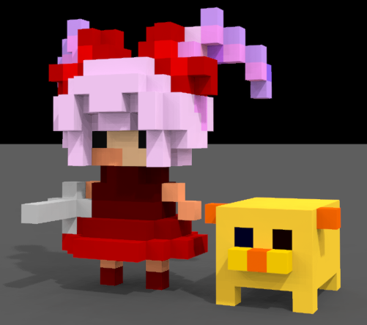

Sari and Matrix

There are two players in this version.

Sari the girl as the main character, and Matrix the dog as the assistant.

You can control them as a team and choose either of them as the team leader.

## Character #1 Sari

Sari the hero, an eight years old human girl, sword in hand and dress in finery.

In this game, Sari takes the part of action.

### Background:

Sari waked up and found herself in the forest and could not remember anything. The only thing with her is her pet Martix. To get her memory back and find out why she stay here and what she would do.

### Weapon and skills:

Sari can use all kinds of swords but no ranged weapon. She can pick up her first weapon in the forest when she meets her enemy the first time.

Sari can use normal attack and one special skill. The type of skill depends on the sword she using. Such as cricle slash or sudden thrust.

### Special ability:

Cross some special terrain, such as the thorny road and trapeze or tightrope in the air.

## Character #2 Matrix

An elder pet dog of Sari, ten years old, looks like a cube in this voxel world .short legs and short tail. In this game, Matrix takes the part of puzzle.

### Background:

Sari is his best friend and he will never leave her away.

### Weapon and skills:

Matrix carries a toy canon on his back, so he can use ranged attack to make small damage. He can also bite or bark as a real dog when the targets are near.

### Special ability:

As a dog, Matrix is alert and has the good sense of smell. When Matrix acts as the team leader, he can show the direction of treasure, and see some hidden things.

Transform is the most important ability of Matrix. He can learn from the environment and change his form to all the weapons or ancient ruins he meets. It is useful when solving puzzle, but if he cannot see Sari, his ability will invalid.

# Non-Player Characters

When Sari and Matrix exploring the forest, they will face some kinds of enemy, or meet some mentor, business man and so on.

## Character #1 the owl

Mentor, the nameless owl, worthy of the forest.

It was trapped in the cage and set free by Sari. When Sari finds some piece of memory, she must take it to the owl to decode it.

## Character #2 business man

Business men, hide in the forest and can be find by Matrix’s nose.

For some reason, they never use money but just exchange things. Sari can exchange or compound items with them.

# Enemies

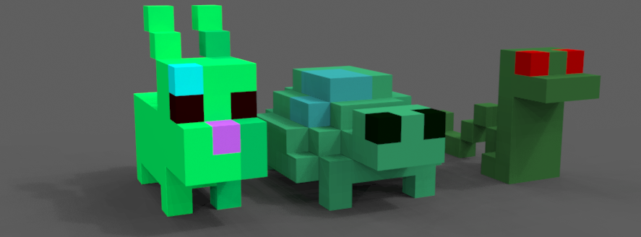

bunny turtle and snake

## Friendly animals

Such as bunny, rat, bird, and some other cute small peaceful creature, always in zombie green.

They attack when player hurt them and make a tiny damage.

## Predator

Bigger zombie animals, such as cat, snake, wolf. They attack the player when they go nearby.

## Stage boss

Some large, strong creature which block the way to the next area.

They can be friendly or hostility, the player should take them down by solving puzzle or fighting.

# Settings

The world in this game is depends on the real world but all looks in zombie green. All the creatures become anomalous except the player and some special character. The adventure of our hero is to find out what happened to this world.

The world is divided to several parts; each hides a piece of memory. Each part of the world has four small levels and a stage boss in the forth level.

When the players clear one stage and jump to another, they will find it was influenced by the crash deeper and deeper.

# Storyline

The time line in this game refers to the sequence of the world open, but can be explained as a flashback also. The sequence of cure the word also shows how the crashes happen. The whole story will show after all the worlds are cleared.

## World #1 the forest

It is the train level which mainly shows how the world runs and tells very little story.

A peaceful forest with sunshine through the leaves. Some ruins of city lay behind the trees. The world is all in silence expect the steps on the grass. The animals are friendly and shy.

Sari and Matrix wake up and start their journey here. The changes have not taken place for so long and the affect is not distinct. So the animals are not aggressive, and the environment is basically safe.

Players can gather the character, then find the weapon, have a train to get use to the weapon in different situation. At the end of this world, the players meet the mentor and some friends. They help the players build their camping ground and open the portal to the next world.

## World #2 the cave

It is the sanctuary for human when the Tragedy strikes .there are marks of human activity but no human seem to be here. Empty cans and lay here and there, the echo will bring the dangers predators when someone kicks the cans.

The portal set Sari here and then they find the way was blocked. The player should fight the enemy and find the exit in the maze. There are several paintings on the wall, which show the story.

While reading the paintings, Sari knows what happened here several years ago. Human lived in the sanctuary until one day someone took an injured cat in. Human set the fox to keep the cheese and the cat brought the wolves into the house. The landslide and the human were forced to leave their home.

## World #N ……

There will be several pieces of world to complete the whole world. The players will find out how the war take place, where the human and the animals go, why the world become like this and so on. And the world will be cured by Sari and Matrix with love, courage, and wisdom.